

Self-Assessment Checklist For: ___________________________________ Entering-Level 1
Person’s Name

Record what you think you can do.

In the blank rows, mark what you can do well,
 (1) I can do this easily and well.
√

OR

Mark what is a goal for you.

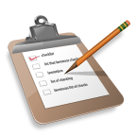 (2) This is one
of my goals.

√

If you have more than half of the items marked as things you can do well, you are at or above the Entering level for that skill.
Self-Assessment Checklist For: ___________________________________ Entering-Level 1
Person’s Name
English as a Second Language | (1) I can do this easily and well. | (2) This is one  of my goals.
INTERPRETIVE
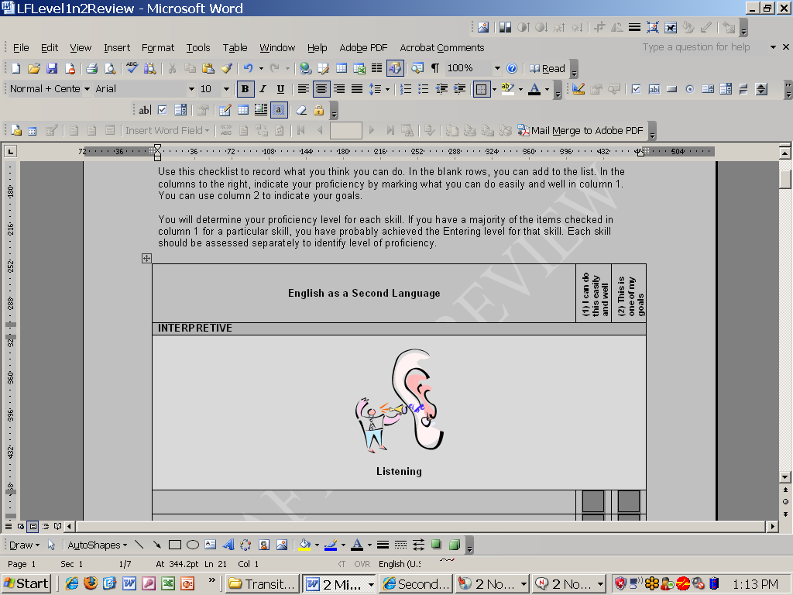
Listening
Page 1 of 2
I can understand greetings.
Hello!

I can follow simple, one-step directions with help.

Draw a rectangle.
I can understand simple questions with help.
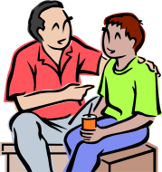
Yes…I…
want…water.
Do you want water?

I can understand what you say when you show me pictures. 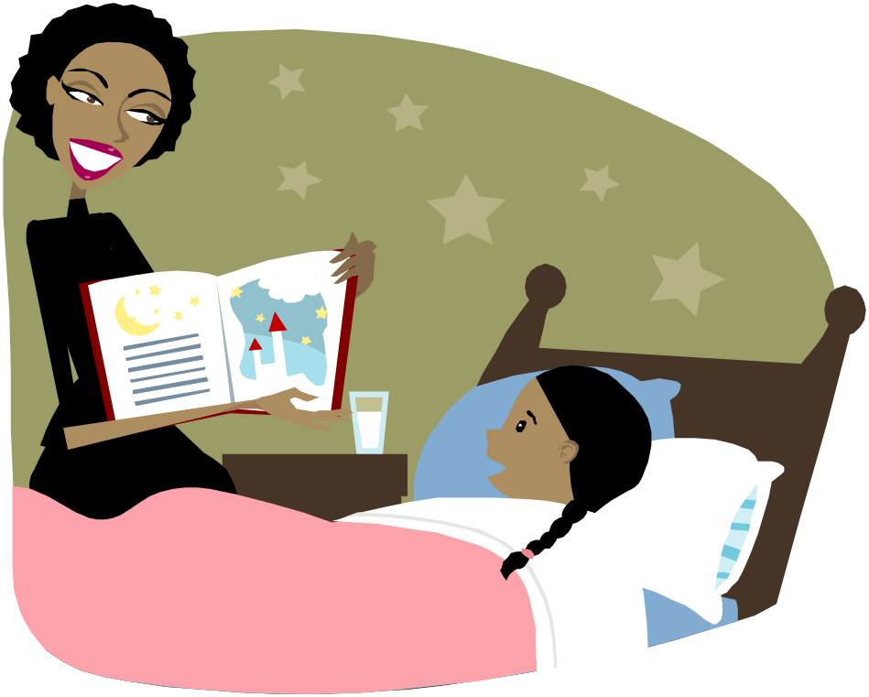
She lives in a big castle.

INTERPRETIVE
Listening
Page 2 of 2
I can show I understand by drawing, matching or acting.

Self-Assessment Checklist For: ___________________________________ Entering-Level 1
Person’s Name
English as a Second Language | (1) I can do this easily and well. | (2) This is one  of my goals.
INTERPRETIVE

Reading
Page 1 of 2
I can identify letters.
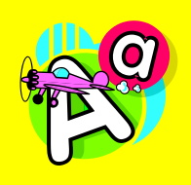
I can identify the sounds the letters make.
aaa!
I can identify familiar names and words.

I can identify familiar phrases and sentences. 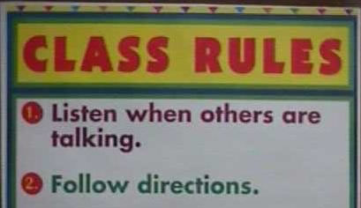
I can read from left to right.


INTERPRETIVE
Reading
Page 2 of 2
I can identify question marks, periods, and exclamation marks.
? . !
I can identify pictures from a story.

I can understand words with picture support.
flower
I can match pictures with words.

dog


cat

Self-Assessment Checklist For: ___________________________________ Entering-Level 1
Person’s Name
English as a Second Language | (1) I can do this easily and well. | (2) This is one  of my goals.
INTERPERSONAL

Speaking in Person-to-Person Communication
Page 1 of 2
I can use words and simple sentences that I have learned.
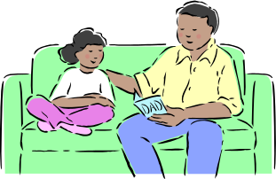
Bed.
Time for bed.
I can greet people.
Bye!

Hello!
I can answer familiar questions.

What is your name?
My name is Pat.
I can tell others what I need.
I need a napkin!

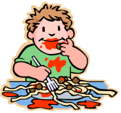

INTERPERSONAL
Speaking in Person-to-Person Communication
Page 2 of 2
I can use basic classroom words.
eraser

paper
pencils
Self-Assessment Checklist For: ___________________________________ Entering-Level 1
Person’s Name
English as a Second Language | (1) I can do this easily and well. | (2) This is one  of my goals.
PRESENTATIONAL

Speaking in Presentations
Page 1 of 2
I can repeat words and simple sentences that I hear.
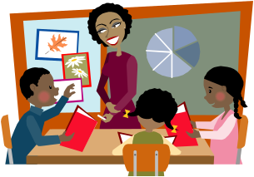
Open your book.
Book.
I can say words and sentences that I have learned.
Open your book.
I can name people, places and objects.

dad
son
book
appy
I can pronounce English sounds and words that I have learned.
aaa…..
airplane

PRESENTATIONAL
Speaking in Presentations
Page 2 of 2
I can answer familiar questions.
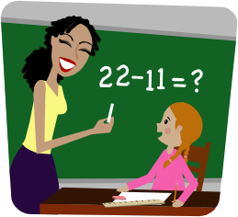
11
What is the answer?
Self-Assessment Checklist For: ___________________________________ Entering-Level 1
Person’s Name
English as a Second Language | (1) I can do this easily and well. | (2) This is one  of my goals.
PRESENTATIONAL
Writing
Page 1 of 2
I can copy letters, numbers, words, and simple sentences.


I live in
North
Carolina.

I can write my first and last name.
José
Lopez
I can label pictures, objects, and charts with help.

red apple
brown stem

PRESENTATIONAL
Writing
Page 2 of 2
I can write some words and simple sentences.
I eat pizza.

I like my friend.

I ride a bike.
I can use capital letters and periods when I write.
I live in
North
Carolina.

Self-Assessment Checklist For: ________________________________Beginning/Emerging-Level 2
Person’s Name

Record what you think you can do.

In the blank rows, mark what you can do well,
(1) I can do this easily and well.
√

OR

Mark what is a goal for you.

(2) This is one
of my goals.

√

If you have more than half of the items marked as things you can do well, you are at or above the Beginning/Emerging level for that skill.

English as a Second Language | (1) I can do this easily and well. | (2) This is one  of my goals.
INTERPRETIVE
Listening
Page 1 of 2
I can understand simple sentences when people speak slowly or repeat.

I am going to school.
I can follow two-step directions.
Example: Go to the door and open it.

I can understand questions about school topics with help.
I learned the earth goes around the sun.

What did you learn in science about planets?

INTERPRETIVE
Listening
Page 2 of 2
I can sort or match pictures to show that I understand a classroom lesson.


sun
earth
I can understand a story with pictures when it is read to me. 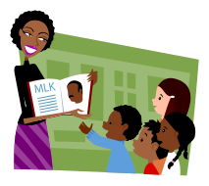
I can understand the main idea of a lesson or message.

I can understand basic information and simple presentations.

English as a Second Language | (1) I can do this easily and well. | (2) This is one  of my goals.
INTERPRETIVE
Reading
Page 1 of 2
I can put letter sounds together to make words.
b…oo…k…book
I can understand familiar signs and messages in the school and community.

I can read and understand vocabulary words from my classes.
sun
tree
plant
I can follow simple written directions to complete assignments and tests, with help.

INTERPRETIVE
Reading
Page 2 of 2
I can understand information from charts, tables and graphs I have learned.
This is a pie chart.
I can find and understand information on familiar topics with help.

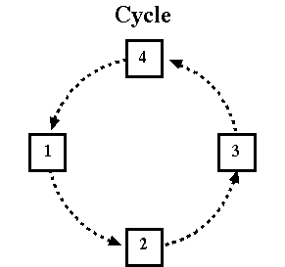
I can understand the main topics and some details in familiar texts with help.
I can understand simple written questions on familiar topics.

Self-Assessment Checklist For: ________________________________Beginning/Emerging-Level 2 Person’s Name
English as a Second Language | (1) I can do this easily and well. | (2) This is one  of my goals.
INTERPERSONAL
Speaking in Person-to-Person Communication

I can answer familiar questions with a simple sentence.
Yes, math was easy.
Did you finish your homework?
I can use simple words and phrases to describe myself, my family and school.

I can describe people, places and things.
This spaghetti is good!
I can ask simple questions about familiar topics.

I can understand conversations about familiar topics.

English as a Second Language | (1) I can do this easily and well. | (2) This is one  of my goals.
PRESENTATIONAL
Speaking in Presentations
Page 1 of 2
I can repeat or sing simple rhymes, poems or songs.

I can use sentences to describe people, places, and objects.
The sun is yellow and hot.
It makes plants grow.

I can use classroom words and sentences.

I can restate simple instructions and directions.

I can answer questions at school.

I can restate facts that I have learned.
This is Martin Luther King, Jr.
He helped many people.

PRESENTATIONAL
Speaking in Presentations
Page 2 of 2

English as a Second Language | (1) I can do this easily and well. | (2) This is one  of my goals.
PRESENTATIONAL
Writing
Page 1 of 2
I can write words, sentences, and facts I have learned.
I live in the U.S.A.

I can describe familiar pictures, facts, and events using sentences, with help.

I can check my writing for capital letters, commas, and periods.
Is this correct?
The map shows states, rivers, and roads.

I can describe a class experiment or activity with words or simple sentences.

PRESENTATIONAL
Writing
Page 2 of 2
I can write notes and short messages.

I can copy sentences and class notes.

Self-Assessment Checklist For: ___________________________________ Developing-Level 3
Person’s Name

Use this checklist to record what you think you can do. In the blank rows, you can add to the list. In the columns to the right, indicate your proficiency by marking what you can do easily and well in column 1. You can use column 2 to indicate your goals.

You will determine your proficiency level for each skill. If you have a majority of the items checked in column 1 for a particular skill, you have probably achieved the Developing level for that skill. Each skill should be assessed separately to identify level of proficiency.
English as a Second Language | (1) I can do this easily and well | (2) This is one of my goals
INTERPRETIVE
Listening
I can understand and follow directions on familiar social, classroom and academic topics.

I can understand questions on different topics, if I can ask for the questions to be repeated when needed.
I can group information that I hear or put it in order using pictures, illustrations, or objects.

I can understand simple stories or conversations about familiar social, classroom and academic topics in class.
I can select the main idea and some details of TV programs or films on familiar social, classroom and academic topics.
I can identify key words and important ideas during a group discussion in class.

Reading
I can follow written instructions to complete assignments and tests.

I can understand information from charts, tables and graphs.

I can use context clues to understand the meaning of words.

I can find information I need for assignments in simple nonfiction texts or reference materials.
I can understand main ideas and some details in paragraphs, if there are pictures, illustrations, or familiar words to help me.
I can put pictures and/or sentences in order to show the main idea of a story.

I can read and understand a book that I choose.

Self-Assessment Checklist Developing-Level 3
English as a Second Language | (1) I can do this easily and well | (2) This is one of my goals
INTERPERSONAL
Speaking in Person-to-Person Communication
I can talk about my experiences and/or feelings with my friends.

I can keep a conversation going using simple words, phrases, and sentences.

I can ask and respond to questions about social topics.

I can ask and respond to questions about academic topics.

I can participate in class discussions.

PRESENTATIONAL
Speaking in Presentations
I can pronounce many words and begin to correct my own pronunciation.

I can talk about familiar classroom and academic topics.

I can retell familiar stories, events and other things I learn in class.

I can give short talks or presentations on classroom and academic topics to my class, if I plan and practice what to say.
I can describe classroom rules and daily routines.

I can answer many questions asked by my teacher during class.

Writing
I can combine familiar sentences into short, connected paragraphs with help.

I can write a short, simple paragraph describing myself, others, and class activities.

I can write postcards, poems, and personal letters.

I can edit my writing for capital letters, punctuation, spelling, and word order, then check/edit with a partner.
I can take notes during my classes with help from the teacher.

I can compare and contrast information I learn from charts, illustrations or diagrams.

Self-Assessment Checklist For: ___________________________________ Expanding-Level 4
Person’s Name

Use this checklist to record what you think you can do. In the blank rows, you can add to the list. In the columns to the right, indicate your proficiency by marking what you can do easily and well in column 1. You can use column 2 to indicate your goals.

You will determine your proficiency level for each skill. If you have a majority of the items checked in column 1 for a particular skill, you have probably achieved the Expanding level for that skill. Each skill should be assessed separately to identify level of proficiency.
English as a Second Language | (1) I can do this easily and well | (2) This is one of my goals
INTERPRETIVE
Listening
I can understand and follow directions on familiar and unfamiliar topics.

I can usually understand when people talk and ask questions about events in the past, present, or future.
I can understand main ideas and some details from what I hear in class and use the information in class assignments.
I can understand stories or conversations about familiar and some unfamiliar topics.

I can select the main idea and most details of TV programs or films that I watch.
I can compare and contrast information I hear in classroom discussions on a variety of social, classroom and academic topics.
I can understand some jokes from conversations at school or from what I hear on TV, the radio, or in movies.
Reading
I can understand and follow complex instructions to complete assignments.

I can use the diagrams, pictures, illustrations, and captions to skim text and find the main ideas and details.
I can locate main ideas, important facts, and many details in a variety of texts.

I can determine the time, sequence of events, and ideas from the language of the written text.
I can find and use information from newspapers, magazines, the Internet, and other written resources.
I can use language in text to help determine fact, opinion, cause and effect, and emotions.

I can understand familiar poetry, short stories, and plays.

Self-Assessment Checklist Expanding-Level 4

English as a Second Language | (1) I can do this easily and well | (2) This is one of my goals
INTERPERSONAL
Speaking in Person-to-Person Communication
I can participate in conversations about familiar social and academic topics.

I can begin and keep a conversation going with most people who speak English.

I can express my opinion and begin to explain why.

I can often talk about events in the present, past and future in conversation.

I can participate in classroom or academic discussions with a small group or with the whole class.
PRESENTATIONAL
Speaking in Presentations
I can speak with correct pronunciation and expression, so I am easily understood.

I can share what I have learned by retelling stories in my own words or summarizing ideas.
I can describe events in the present, past, and future.

I can give presentations to my class about classroom and academic topics, if I plan and practice what to say.
I can share a report or project I have completed with a small group or the whole class.

I can explain the solution to a math problem using math vocabulary words correctly.

I can express my ideas and opinion in some classroom and academic situations.

Writing
I can edit my writing for capital letters, punctuation, spelling, subject-verb agreement and word choice.
I can write several connected paragraphs on social, classroom or academic topics.

I can draft, edit, and revise an organized essay.

I can complete assignments and write reports about a concept, activity, event, or experiment.
I can write a paragraph that describes strategies for solving problems in math or science class.
I can write a paragraph that describes events in the present, past or future.

I can use some idioms and a variety of vocabulary, including synonyms and compound words in my writing assignments.

Self-Assessment Checklist For: ___________________________________ Bridging-Level 5
Person’s Name

Use this checklist to record what you think you can do. In the blank rows, you can add to the list. In the columns to the right, indicate your proficiency by marking what you can do easily and well in column 1. You can use column 2 to indicate your goals.

You will determine your proficiency level for each skill. If you have a majority of the items checked in column 1 for a particular skill, you have probably achieved the Bridging level for that skill. Each skill should be assessed separately to identify level of proficiency.
English as a Second Language | (1) I can do this easily and well | (2) This is one of my goals
INTERPRETIVE
Listening
I can understand directions about subject area, technical and scientific information.

I can make connections with my experience when people talk about events in the past, present, and future.
I can identify the speaker’s tone, style, and purpose most of the time.

I can understand most TV programs or films on familiar topics and some unfamiliar topics.
I can use information from classroom discussions in assignments and homework.

I can understand most information when slang or different accents are being used.

I can understand jokes and comments about people and ideas from conversations, TV, radio, or film.
Reading
I can identify different types of literature based on the characteristics of the text.

I can find and use information from a variety of sources to complete a specific task or project
I can summarize the main idea and supporting details from a variety of texts.

I can identify elements of fiction and non-fiction and give examples from texts.

I can read and comprehend passages from different textbooks on a variety of topics.

I can understand the meaning of some slang and idioms in written text or literature.

I can analyze a variety of texts for author’s purpose, style, meaning, and mood or tone.

Self-Assessment Checklist Bridging-Level 5

English as a Second Language | (1) I can do this easily and well | (2) This is one of my goals
INTERPERSONAL
Speaking in Person-to-Person Communication
I can talk about events in the present, past and future in conversations or discussions.

I can discuss events that are happening, have happened or might happen, and the listener understands the time of the events when there are no time words.
I can participate in some conversations on unfamiliar topics, even if I don’t know all the words.
I can support my opinions or viewpoint in a conversation or discussion.

I can ask for and give information within a classroom and/or academic discussion.

PRESENTATIONAL
Speaking in Presentations
I can speak with correct pronunciation, fluency and expression, so that native speakers can understand what I say.
I can give presentations to my class on a variety of social, classroom and academic topics.
I can explain how to solve problems using details and technical language.

I can explain cause and effect, scientific processes, and events that might happen.

I can express my opinions with some details in social, classroom and academic situations.

I can respond to questions after making a classroom or academic presentation.

Writing
I can write on a variety of topics in different genres, such as narratives, short stories, reports, and summaries.
I can write in detail about events that occur at different times and in different places.

I can edit and correct my writing for punctuation, spelling, tense, subject-verb agreement, and word choice.
I can adapt my writing style and word choice to a purpose and audience.

I can use idioms and a variety of vocabulary, including synonyms, compound words, and scientific and/or technical language.
I can write an editorial with evidence of my opinions in response to a news article.

Self-Assessment Checklist For: ___________________________________ Reaching-Level 6
Person’s Name

Use this checklist to record what you think you can do. In the blank rows, you can add to the list. In the columns to the right, indicate your proficiency by marking what you can do easily and well in column 1. You can use column 2 to indicate your goals.

You will determine your proficiency level for each skill. If you have a majority of the items checked in column 1 for a particular skill, you have probably achieved the Reaching level for that skill. Each skill should be assessed separately to identify level of proficiency.
English as a Second Language | (1) I can do this easily and well | (2) This is one of my goals
INTERPRETIVE
Listening
I can draw conclusions from information spoken in a variety of dialects and accents.

I can understand information I’m listening to when idioms and slang are used.

I can understand TV programs, films, and documentaries on almost any topic.

I can comprehend scientific or technical language from classroom discussions.

I can identify the speaker’s tone, style, and purpose.

I can determine relationships between concepts that are being discussed in class.

Reading
I can read and comprehend different styles of writing in literature.

I can independently read and comprehend grade level texts on a variety of topics.

I can understand the meaning of slang and idioms in written text or literature.

I can analyze texts independently for a variety of purposes and meanings.

I can do research by reading independently, using a variety of resources.

Self-Assessment Checklist Reaching-Level 6

English as a Second Language | (1) I can do this easily and well | (2) This is one of my goals
INTERPERSONAL
Speaking in Person-to-Person Communication
I can participate effectively in conversations and discussions.

I can use appropriate language in all conversations and discussions.

I can express and support my opinions or viewpoint.

I can lead a classroom or academic discussion.

I can describe events that occur at different times and in different places with ease.

PRESENTATIONAL
Speaking in Presentations
I can give effective oral presentations on a variety of topics, using technical language.

I can describe events that occur at different times and in different places with ease.

I can speak fluently with expression, using slang or idioms when it is appropriate.

I can express and support opinions or viewpoints on a variety of topics.

I can respond appropriately to an audience during and after a presentation.

Writing
I can write in a variety of genres and styles for different audiences.

I can write about events that occur at different times and in different places with ease.

I can write for social and academic purposes with ease.

I can adapt my writing style and word choice according to purpose and audience with ease.
I can independently edit and correct my writing for punctuation, spelling, tense, subject-verb agreement, and word choice.
I can use idioms and a variety of vocabulary, including synonyms, compound words, and classroom or academic terms.

